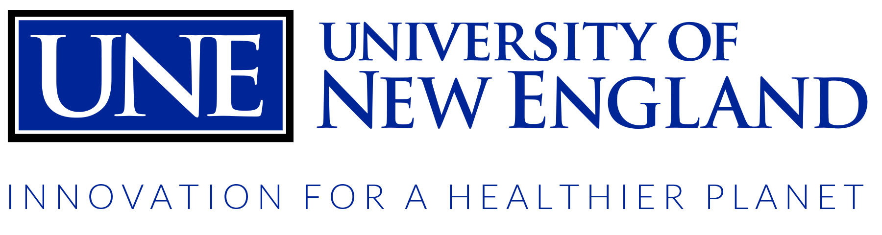
Group Exercise Schedule
January 25th – May 6th, 2016

MONDAY | TUESDAY | WEDNESDAY | THURSDAY | FRIDAY
HeartWISE  Gym  7-7:45am  Caroline  AquaWISE  Pool  8:15-9am  Katie  Tai Chi  MPR’s  9:30-10:30am  Raymond  AquaWISE  Pool  10:45-11:30am  Lyndie  Spin & Core  RBC  12-1pm  Lori  Zumba  MPR’s  7-8pm  Chole | Nor’easter Xpress  Fitness Center  7:30-8am  Finn  Balance & Bend  Fitness Center  8:30-9:30am  Rachel  Ask the Trainer…  Fitness Center  11-12pm  Lyndie | HeartWISE  Gym  7-7:45am  Caroline  AquaWISE  Pool  8:15-9am  Katie  AquaWISE  Pool  10:45-11:30am  Laura  Spin & Core  RBC  12-1pm  Lori  Zumba  MPR’s  7-8pm  Chole | Nor’easter Xpress  Fitness Center  7:30-8am  Finn  Balance & Bend  Fitness Center  8:30-9:30am  Rachel  AquaWISE  Pool  10:45-11:30am  Finn  Zumba  MPR’s  4-5pm  Jo  Salsa  MPR’s  7-8pm  Wendy | HeartWISE  Gym  7-7:45am  Caroline  AquaWISE  Pool  8:15-9am  Katie  Spin & Core  RBC  12-1pm  Lori
All classes are open to BodyWISE members as well as all UNE students, staff & faculty
Note: All classes are subject to change or cancellation
Group Exercise Class Descriptions

AquaWISE: Dive on in to this low-impact but high-intensity pool workout! This total body workout will challenge your major muscle groups, improve your cardiovascular stamina, and enhance flexibility and joint range of motion.

HeartWISE: Monitor your heart rate and blood pressure before and after exercise during this class. Get any questions you have regarding diet, exercise, and stress reduction answered during this session!

Nor’easter Xpress: Want to get a great workout in before work or class? Get in and out with this 30-minute, fast-paced metabolic circuit session – build and sculpt muscle, burn body fat and build endurance all before your first class or work of the day.

Balance & Bend: Regain balance and bodily awareness while you strength train!
This weight lifting based class will help you build strength, enhance bone mass and increase flexibility levels.

Spin & Core: This class is a traditional group cycling session – with a twist! You’ll start off pedaling and finish planking…you will challenge your core with fun, new exercises while building stamina and improving your percentage of lean body mass.

Zumba: Love to dance? Jump into this fun, fast dance party that feels more like a night out than a workout. Be sure to bring a friend (or 5!).

Salsa: If you are looking to learn a new skill – give Salsa a try! You’ll learn the basics of this dance genre while getting a great total body workout.

FMI – (207) 602-2307 for more information
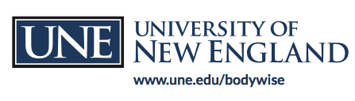
Or email Lyndie Kelley llibby2@une.edu

