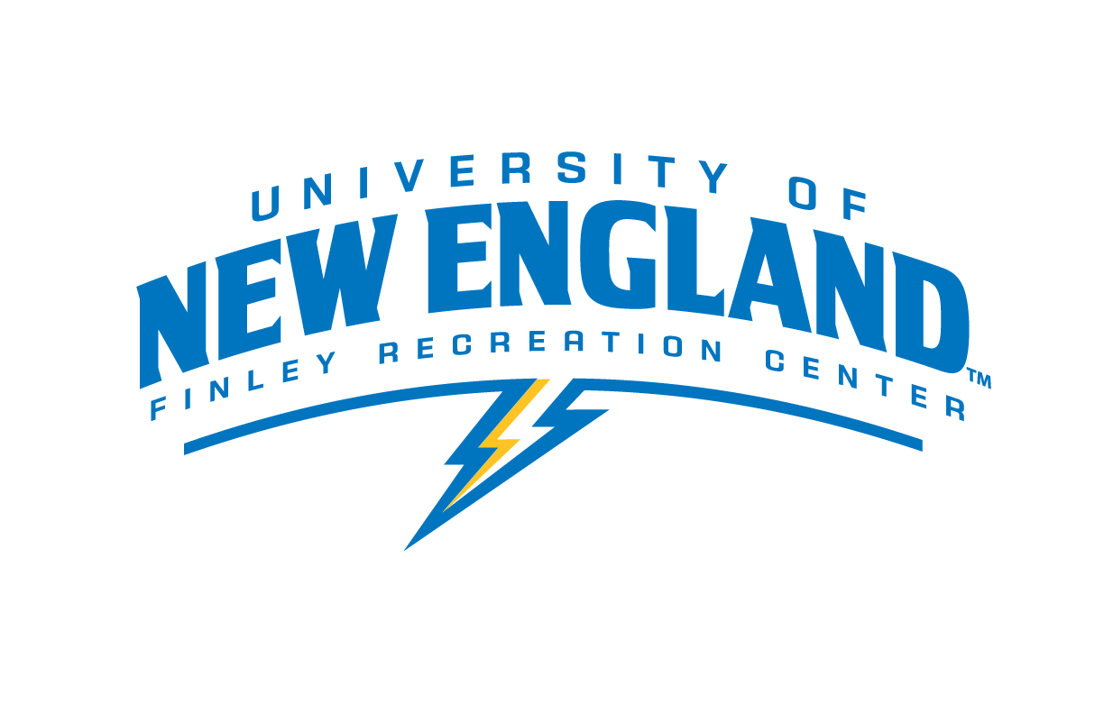

Certified Personal Trainer

Department: Finley Recreation Center
Purpose: Preparing and leading workouts and training sessions for UNE students and employees
Pay Rate: $15.00
Schedule: To be determined by staff availability – Hours are 6am to 10pm Monday through Friday, 8am to 8pm on weekends and are subject to change.

Job Responsibilities:
- Certified Personal Training, or Strength and Conditioning Specialist, or Athletic Trainer
  - ACSM, NSCA, ACE, ISSA, or NATA
- Bachelor’s degree in a related field.
- Experience working as a personal trainer.
- Proven dependability and availability to work evenings and weekends.
- Ability to communicate effectively with client and supervisor.
- Demonstrated ability to explain proper form and technique.
- Must possess outstanding customer service skills.
- Must be a team player and willing to work as a committed member in the Finley Recreation Center.
- Possess a desire to work for the program and demonstrates initiative.
- Must be knowledgeable or have to ability to gain knowledge in field related topics.
- Submit one monthly social media post supported through research
- Must work with-in the Scope of Practice of a Certified Personal Trainer.
Job Requirements and/or Qualifications:

- To be a positive representative of the Finley Recreation Center and act as a liaison for clients and professional staff.
- Responsible for scheduling their clients and finding balance between work, academics, etc.
- Responsible for attending all staff meetings and training sessions.
- Directly responsible for preparing workouts and training programs.
- Must be able to consult with the Finley Recreation Center’s professional staff on all matters.
- Consistently work to maintain a safe environment for clients.
- Responsible for collecting and filing waivers, fitness assessment data, etc
- Make training decisions based on established policies and procedures using sound judgment.
- Responsible for performing other duties as assigned by the Finley Recreation Center’s professional staff.
- CPR Certification and First Aid Certification required (can obtain after getting hired).
Employment Agreement:

As a representative of UNE, you are expected to be a role model, exhibiting appropriate behavior at all times. Violations of the University Conduct Code may either prevent your selection for this position or terminate your employment.

The above job description has been fully explained to me by my immediate supervisor. I understand that I will be part of Finley Recreation Center Employment team. I understand the duties as outlined and agree to carry out these responsibilities upon acceptance of this position.

I understand that I if I breach any of the expectations above, I will undergo a “three strike” discipline system that includes the following steps if behavior does not improve:
· A verbal warning and meeting with my lead or staff supervisor(s)
· A written warning and meeting with my lead or staff supervisor(s)
· Termination of employment

Student’s Signature: __________________________________________Date: _________

I have thoroughly discussed the job description and expectations of this position with the student employee whose signature appears above. I agree to provide the training necessary to carry out the above functions successfully.

Supervisor’s Signature: ________________________________________Date: ________

Supervisor(s): Colleen Lundgren, CSCS, CPT, WFR
Email: clundgren@une.edu Phone: 207-221-4556

Supervisor(s): Judy Vezina
Email: jvezina@une.edu Phone: 207-221-4348

