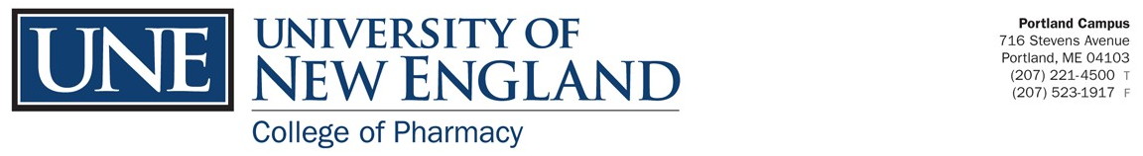
Pharm.D. Program Quality Indicators

Accreditation Status

The University of New England College of Pharmacy’s Doctor of Pharmacy program is accredited by the Accreditation Council for Pharmacy Education (ACPE), 135 South LaSalle Street, Suite 4100, Chicago, IL 60503; Telephone: (312)664-3575, Fax (312) 664-4652;
website: www.acpe-accredit.org.

The New England Association of Schools and Colleges Commission on Institutions of Higher Education (NEASC CIHE) is the regional accrediting agency for over 200 colleges and universities, including the University of New England, in the six New England states: Connecticut, Maine, Massachusetts, New Hampshire, Rhode Island and Vermont. The University of New England is accredited by NEASC and will complete its next comprehensive evaluation in 2027.

On-Time Graduation

Class Year | On Time Graduation Rate
2023 83.7 % (36/43)
Details: 43 students entered in 2019
36 students graduated in May 2023
7 students left the program (3 dismissals; 3 have a 1-year delay in graduation; 1 left voluntarily)

NAPLEX Licensure Information [First Time Test Takers]

Year Pass Rate
2022 83% (45/54)
Residency/Fellowship Placement
Graduating Class Residency/Fellowship Placements Placement Rate
2023 15 out of 37 students 40.5%
17 students applied to AHSP Residencies and 15 matched for an 88% match rate

