Elementary Neuroscience
Grades 3-5

Driving Question: Why is your brain so important and how do different parts of it work together?

Objectives: Students will be able to…
- Demonstrate proper helmet fitting with the Rule of Two’s.
- Describe the basic structure and function of the neuron.
- Describe that different parts of the brain have different functions.

Next Generation Science Standards:
- NHES Standard 1 Students will comprehend concepts related to health promotion and disease prevention to enhance health.
- 5-PS1-3 Make observations and measurements to identify materials based on their properties.
- MS-LS1-2 Develop and use a model to describe the function of a cell as a whole and ways parts of cells contribute to the function.

Materials:
- Bike Safety with Bill Nye video
  - http://www.dep-store.com/ProductDetails.asp?ProductCode=77A92VL00
- Stroop Test Cards
- Pipe Cleaners (5 per student)
- Brain Lobe Coloring Pages

Procedure:
Engage:
- Your brain is a very important part of your body, what is one way that we protect our brain?
- What are some things that your brain helps you do?

Explore:
- Bill Nye Video
- Stroop Test
- Pipe Cleaner Neurons
- Brain Lobe Coloring Pages

Explain:
- Video: Watch the Bike Safety with Bill Nye video.
  - Helmet fitting demonstration using the Rule of Two’s.
  - Use a helmet and ask for a volunteer to properly fit the helmet.
    - Two fingers between the chin and chinstrap.
    - Two fingers distance from the top of the eyebrow to the rim of the helmet.
    - Two finger distance from the bottom of the ear lobe to the strap.
- Stroop Test
  - Divide the students into pairs.
  - Explain that the students will hold up the card and the partner announces the color of the word instead of the word itself, as fast as they can. Hand out the Stroop Test cards and have the students switch roles after a few minutes.
- Pipe Cleaner Neurons
  - Introduce the neuron to the students.
    - Your body is made up of cells.
    - There are many different types of cells that work for different parts of your body.
    - Neurons are cells of the brain and nerves in your body.
  - Introduce the neuron to the students. Draw a neuron on the board as you give a very basic explanation of each part.
    - Soma: the body of an organism, or the “cell body”. Take one pipe cleaner and roll it into a ball to make the soma.
    - Axon: A long, slender projection of the neuron that conducts electrical impulses away from the soma. Take another pipe cleaner and attach it to the soma by pushing it through the ball so there are two halves sticking out. Twist the two halves together to make a single extension.
    - Dendrite: The branching process of a neuron that conducts the electrical signal toward the cell. Use two other pipe cleaners and push them through the soma on the opposite side of the axon. Twist each to secure it in place.
    - Myelin Sheath: A special type of cell that wraps around the axon to insulate and deliver it faster. Wrap the four 1/8-length pipe cleaners along the axon and keep them evenly spaced.
  - The signal enters the dendrites and is sent down the axon.

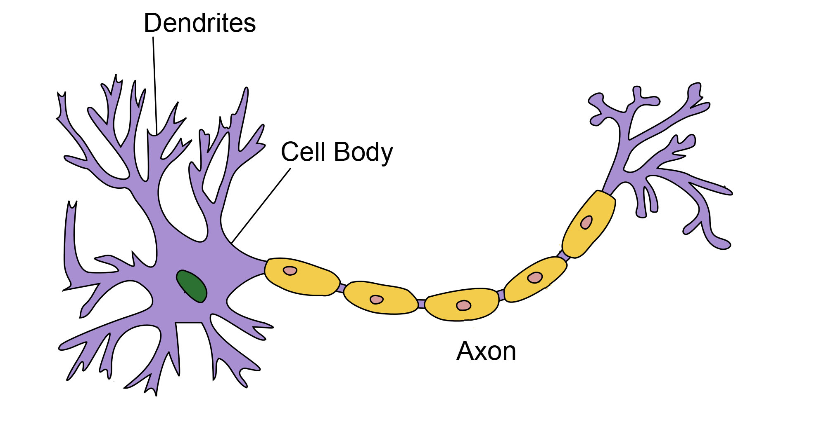

- Brain Lobe Coloring Pages
  - Hand out the brain lobe coloring pages and instruct the students to not draw on it. Before the instructor discusses each lobe, allow the students to color it in.
  - The depth of information may vary depending on the class.
    - Frontal Lobe: Located on the front of the brain. It is used in decision making, some muscle movement
    - Parietal Lobe: Located on the top of the brain. Used for sensation (touch), and integration of all senses.
    - Temporal Lobe: located on the sides above the ears. They are for hearing and memory.
    - Occipital Lobe: Located on the back and it is used for sight (vision)
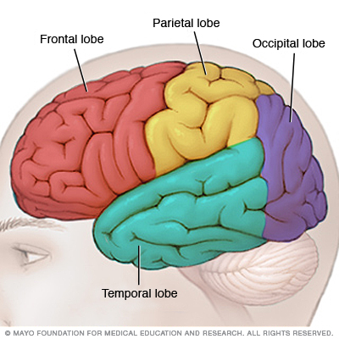

Elaborate:
- Stroop Test
  - The words of the Stroop Test have a strong influence on the ability to say the color. The interference between the different information your brain receives causes a problem. There are two theories that may explain the Stroop Test.
    - Speed of Processing Theory: the interference occurs because the words are read faster than the colors are named.
    - Selective Attention Theory: the interferences occur because naming colors requires more attention than reading the words.
  - The puzzle may be easier for a young child than an adult because younger children may know their colors but they cannot yet read.
- Pipe Cleaner Neurons
  - Neurons are used to send information from your body to your brain, and vice versa.
  - Pretend that you stepped on something sharp and you immediately jump away because it hurt. The cells in your foot sensed that the sharp object was hurting it. The neurons in your foot sent that information of pain to your brain very quickly! The information went from your foot to your brain by using neurons to send the signal. Your brain sent information to your body to quickly move yourself away from the sharp object. That entire process can happen in a matter of milliseconds!

Evaluate:
- Did the CEN Outreach volunteer teach the student objectives?
- Did the CEN Outreach program reach the goals of the teacher?
- Did the CEN Outreach program reach it’s own goals/objectives?

NGSS Description:
- NHES Standard 1 Students will comprehend concepts related to health promotion and disease prevention to enhance health.
Students will demonstrate NHES Standard 1 during the discussion of brain lobes and neurons. They learn the importance and function of the brain and that neurons are special cells that send information all over the body. The discussion is based around brain health, function, and safety to influence health and well-being.

- 5-PS1-3 Make observations and measurements to identify materials based on their properties.
Students will demonstrate 5-PS1-3 during the discussion of helmet safety using the Bill Nye video. Helmets have a specific design to keep the brain safe. The straps, shell, padding, and structure contribute to safety and function.

- MS-LS1-2 Develop and use a model to describe the function of a cell as a whole and ways parts of cells contribute to the function.
Students will demonstrate MS-LS1-2 when they create neurons out of pipe cleaners. The structure and function of the cell is discussed during this hands-on activity as well as how multiple parts of it works together.

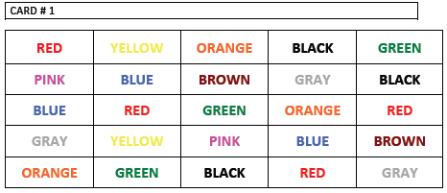
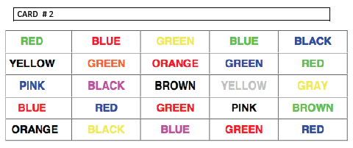
Stroop Test Cards

