*Sponsored By:*

# **Resources for help:**

Portland Recovery Community Center

468 Forest Avenue, Portland

(207)-553-2575

Operation HOPE - Scarborough Police Department

246 US Route 1, Scarborough

Young People in Recovery (YPR)

Portland Chapter

PortlandME@Youngpeopleinrecovery.org

Mercy Hospital - Adult and Youth Outpatient Services

Portland

(207)-879-3600

Recovery Maine - Adult Outpatient Services

N. Berwick

(207)-558-2111

Crossroads – Adult and Youth Outpatient Services

Kennebunk

(207)-467-3309

For a complete listing, visit: https://findtreatment.samhsa.gov/

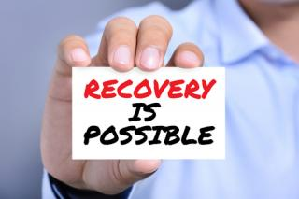

http://www.townofboscawen.org/health-officer/pages/substance-use-disorder-information-resources

http://www.townofboscawen.org/health-officer/pages/substance-use-disorder-information-resources

Substance Use Disorder:

Science Stigma and Struggle

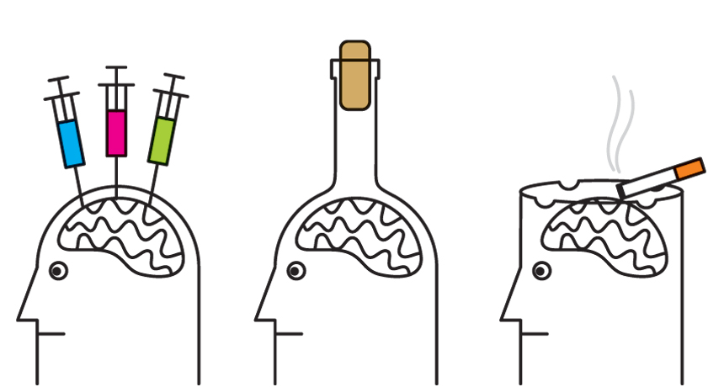

https://www.pinterest.com/hugsnotdrugsjax/drug-abuse-effects-this-is-your-brain-on-drugs/?lp=true

*Supplemental Information*

# **Community Responses:**

**How can a healthcare provider better care for patients suffering from a Substance Use Disorder?**

*“Get educated. There’s so much information out there about these issues. Read about trauma. read about SUDs. Read about psychology. Read about healing.”*

*“We are not bad people, just people that never learned the life skills we need to walk through life without trying to numb out the uncomfortable feelings that life brings.”*

*“Don't tell them to "just quit". Don't wince when your patient speaks up, instead thank them for their honesty. KNOW your local resources for referrals.”*

*“Show empathy and make a connection.”*

*“Provider and healthcare language is often so stigmatizing and so shaming. We are not 'abusers.' We have most often been abused and have found a way to live life on life's terms, post traumatic event.”*

*“.. don't discriminate against us when we do need help with pain. Part of what we learn in NA is how to keep ourselves safe during these times. I feel discriminated against sometimes.”*





# **Community Responses:**

**If there was one thing you wanted others to understand about addiction, what would it be?**

*“It's not a moral failing.”*

*“I did choose to use. I didn't choose to gain an obsession and compulsion. Doesn't mean I didn't deserve help to get better. If I brake my leg rock climbing, I'm no less deserving of help than someone who broke their leg by no fault of their own decision.”*

*“It was the only tangible treatment option I could find. Trauma plays such a massive role in SUD development and the only thing that brought me relief from the mental emotional and physical pain was drugs and alcohol.”*

*“It can always be you.”*

*“It’s certainly not a choice. For me it was a symptom - it was a result of un-processed/ un-healed childhood trauma - and the pain and anger that had to go somewhere - and thus got directed inward. When a kid is abused they can't blame their abuser - so they blame themselves - and this starts this long process of self-harm and self-obliteration - but its subconscious.”*

## **Community Responses:**

**What was the biggest challenge you faced while suffering from your Substance Use Disorder?**

*“Living day-to-day. Not being able to see and think and plan for future goals.”*

*“A lack of fulfillment from the people around me and my daily activities.”*

*“Having to choose between quitting my job (as a single parent) and not getting treatment.”*

*“Stigma and shame played a huge role in taking so long for me to get help. I did not feel like I qualified for services, and then didn't feel like I deserved them.”*

**What was the biggest transition from active use to sober living? What is key for you to maintain sobriety?**

The most common reported obstacle in the transition from active use to recovery was the need to change environment, including established social groups. In addition, the most common response when asked about their “key to sobriety” involved maintaining support from family, friends, and allies within the community

**In the Media:**

* “And these devils they keep talkin’ to me, they screamin’ “open the bottle,” I want to be at peace. My hand is gripping that throttle, I’m running out of speed, tryin’ to close my eyes but I just keep sweatin’ through these sheets.”

– Drug Dealer by Macklemore

* “My organs were shutting down, my liver, my kidneys, everything. They didn’t think I was going to make it. My bottom was going to be death”

– Eminem

* “I have completed treatment for alcohol addiction; something I’ve dealt with in the past and will continue to confront…I want my kids to know there is no shame in getting help when you need it…”

– Ben Affleck

**Learn More:**

* TED Talks:
  + “How childhood trauma affects health across a lifetime” by Nadine Harris
  + “Everything you think you know about addiction is wrong” by Johann Hari
* HBO Addiction Series
* Online Resources:
  + Facesandvoicesofrecovery.org
  + Drugabuse.gov
  + Adolescenthealth.org/resources/clinicalcareresources/substanceuse

Addictionblog.org

http://www.businessinsider.com/ben-affleck-treated-for-alcohol-addiction-2017-3

TED.com

Addictionblog.org

http://www.businessinsider.com/ben-affleck-treated-for-alcohol-addiction-2017-3

TED.com