Finley Recreation Center
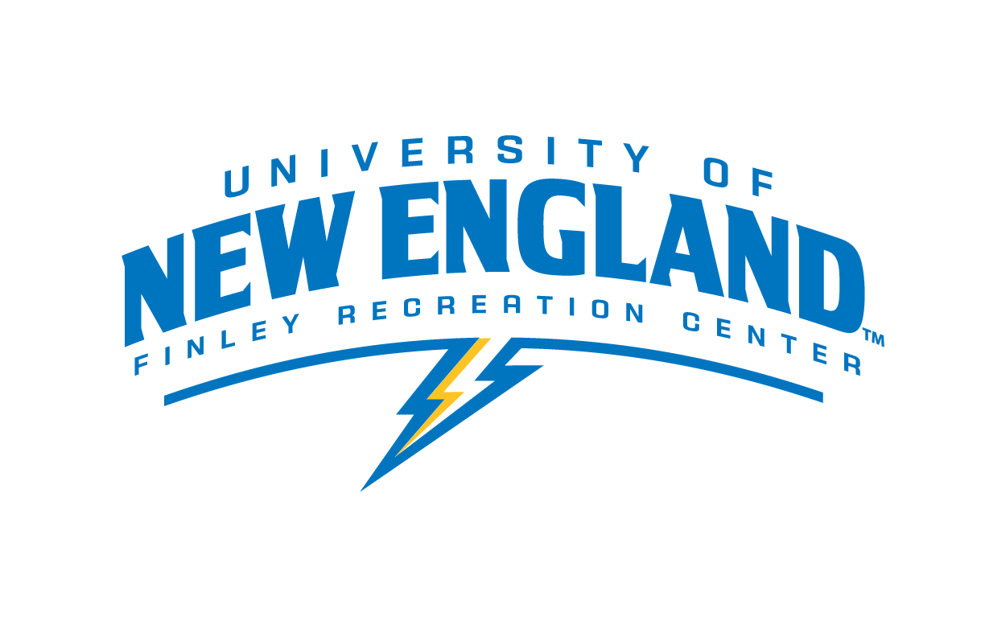
Student Front Desk Manager

Department: Finley Recreation Center
Purpose: To provide training and guidance for all front desk staff employed at the Finley Recreation Center along with administrative tasks
Federal Work Study Pay Rate: $10.10 in addition to a $200 reward at the end of the summer, fall, and spring semesters
Schedule: To be determined by staff availability – Hours are 6am to 10pm Monday through Friday, 8am to 8pm on weekends and are subject to change.

Job Responsibilities:
- Assist in training front desk staff
- Maintain all forms at the front desk: (waiver and release forms, accident reports, sign in sheets, hourly check sheets, and opening and closing procedures)
- Maintain and tally Student Fitness Challenge logs and post weekly updates on bulletin board
- Confirm accuracy of tallied usage reports
- Cover desk in case of last minute call-outs/no-shows, etc. (as allowed by academic schedule)
- Attend check-in meetings with supervisors, as necessary
- Assist and participate in Finley events as allowed by academic schedule: (Health Fair, Stress Relief Series, Earth Day, Bragging Rights Challenge, Lunch ‘n Learns, etc.)

Job Requirements and/or Qualifications:

- Applicants will be selected based on the following criteria:
  - A desire to train and work with new staff
  - Commitment to the overall function and appearance of the Finley Recreation Center
  - Effective communication, organization, and problem solving skills, and attention to detail
  - Positive role model for community
- Prior work experience in the Finley Recreation Center or some college level leadership position preferred
- Must be available for early morning, late evening, and weekend staffing emergencies
- Available to cover shifts not covered by regular staff
Employment Agreement:

As a representative of UNE, you are expected to be a role model, exhibiting appropriate behavior at all times. Violations of the University Conduct Code may either prevent your selection for this position or terminate your employment.

The above job description has been fully explained to me by my immediate supervisor. I understand that I will be part of Finley Recreation Center Employment team. I understand the duties as outlined and agree to carry out these responsibilities upon acceptance of this position.

I understand that I if I breach any of the expectations above, I will be undergo a “three strike” discipline system that includes the following steps if behavior does not improve:
· A verbal warning and meeting with my lead or staff supervisor(s)
· A written warning and meeting with my lead or staff supervisor(s)
· Termination of employment

Student’s Signature: __________________________________________Date: _________

I have thoroughly discussed the job description and expectations of this position with the student employee whose signature appears above. I agree to provide the training necessary to carry out the above functions successfully.

Supervisor’s Signature: ________________________________________Date: ________

Supervisor(s): Colleen Lundgren, CSCS, CPT, WFR
Email: clundgren@une.edu Phone: 207-221-4556

Supervisor(s): Judy Vezina
Email: jvezina@une.edu Phone: 207-221-4348

